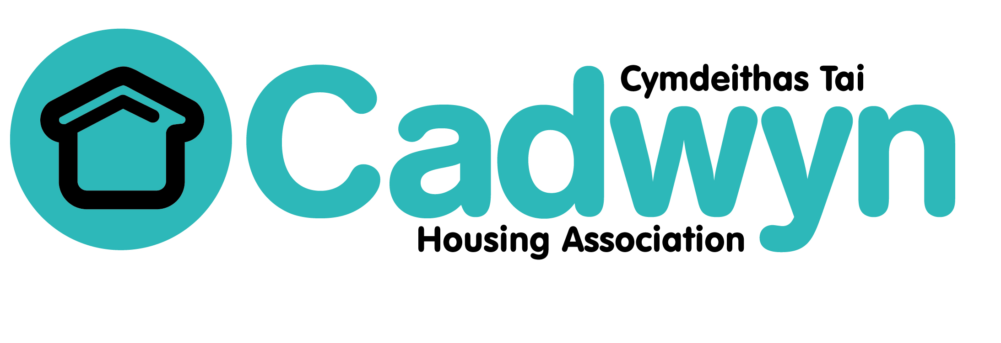

Obligations of the Board

Date of Board Approval: Oct 2009 | Authorised by: Board
Author: Chris O'Meara | Designation: Chief Executive
Document version: v4 (reviewed August 2018)
Next review: August 2019

Our mission is:

“…Cadwyn provides good quality homes and builds communities through partnership and innovation.”

Our vision is:

“To be leading and innovative, enabling people and communities to realise their potential”

Our Values are:

- To aim for excellence in everything that we do;
- To empower staff and tenants;
- To be committed to sustainability;
- To be innovative;
- To have both personal and organisational integrity;
- To be business like;
- To achieve equality and diversity;
- To be accountable.

Key Results for the future

There are four key results we are aiming to achieve through everything we do. These are:
- People live and work in environmentally sustainable homes, workplaces and communities
- People have access to well managed and maintained homes
- People live in communities that are strong and resilient
- Cadwyn is a strong and independent social enterprise valued for our contribution

Obligations of the Board

- To agree the strategic objectives and values and ensure that policies and procedures are in place to achieve them.

- To monitor performance to ensure that a high level of service is delivered.

- To approve the Annual Budget and all Accounts on an annual basis.

- To oversee the framework of delegation and systems of control.

- To identify risks and ensure that they are managed.

- To appoint (and if necessary remove) the Chief Executive.

- To ensure that all business is conducted with propriety.

- To have overall responsibility for Health & Safety, and the welfare of Cadwyn’s employees

- To abide by the Board Member Code of Conduct

- To abide by the CHC Code of Governance

- To take suitable and appropriate advice when required.

- To complete a Declaration of Interest form annually.

I confirm that I understand and accept the obligations of a Cadwyn Board Member. I also confirm that as a shareholder, I will act at all times in the interests of the association and for the benefit of the community.

Signed:

Name: Date:

