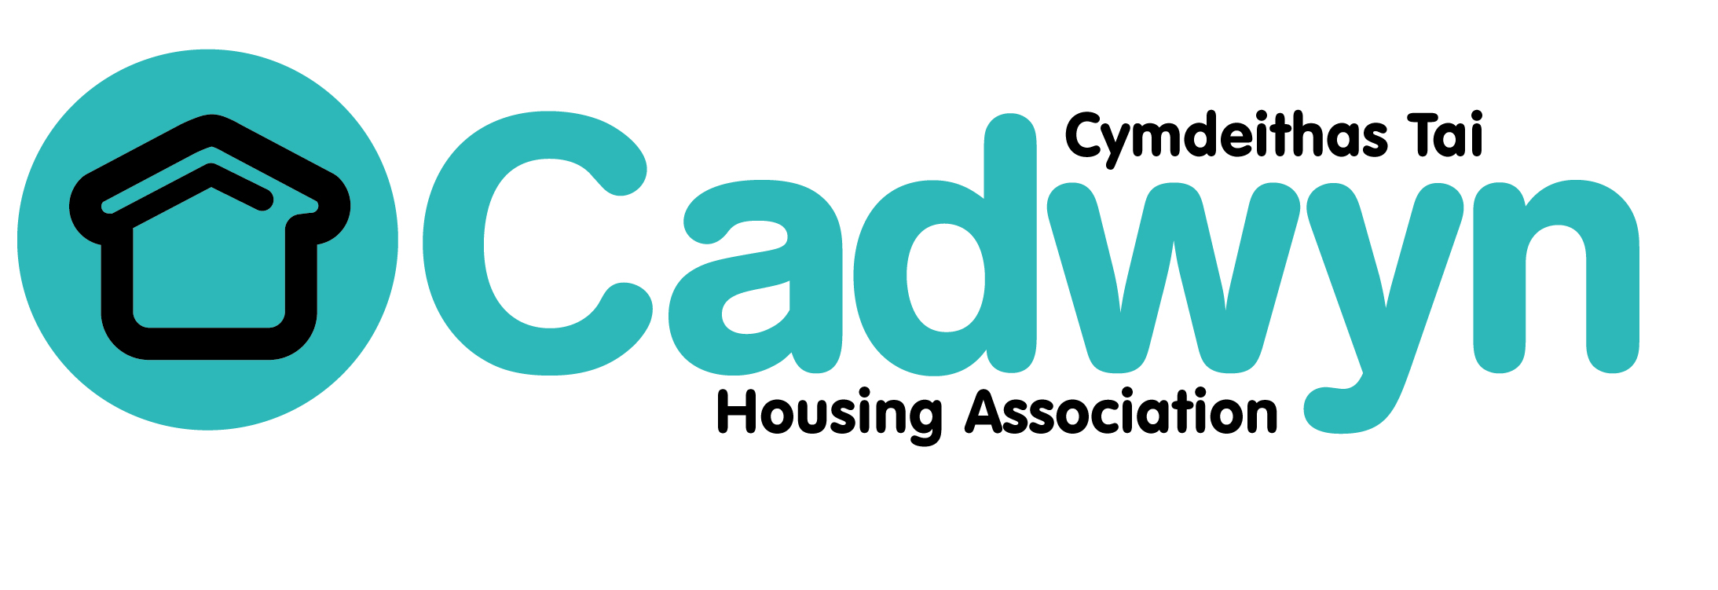

Terms of Reference for the Board

Date of Board Approval: Oct 2009 | Authorised by: Board
Author: Chris O'Meara | Designation: Chief Executive
Document version: v5 Nov 18
Next Review: Nov 2019

Terms of Reference for the Board
Approved at Board September 2018

CONSTITUTION, COMPOSITION AND FUNCTIONS OF THE BOARD

The Board is primarily a group of Shareholding Members, who direct the affairs of the Association. The Board has ultimate responsibility for the governance of the Association. The Board’s central role is to direct the organisation’s work, that is, to determine strategic direction and policies and to ensure that agreed strategies and policies are delivered. The implementation of the Board’s policies is delegated to the paid staff of the Association.
The Rules of the Association set out in broad terms the Board’s functions, rules on who may be Board members, how elections are to be carried out, and the management of Board meetings.
Amongst its functions shall be to:
- defining and ensuring compliance with the organisation’s values and strategic objectives;
- establishing a framework for approving strategies, policies and plans to achieve those objectives;
- identifying appropriate resources to put strategy and policy into practice, satisfying itself as to the integrity of financial information and approving annual budgets and accounts and business plans;
- ensuring effective systems for evaluating the work of the organisation, internal control, risk management and communication and engagement with service users and stakeholders, (including in relation to setting strategic direction), are in place;
- establishing and monitoring a framework for delegation and systems of internal control which are reviewed annually;
- taking decisions and agreeing policies on all matters that might create a significant financial or other risk to the organisation or that raise significant issues of principle
- establishing mechanisms for communication and receiving feedback from the organisation’s stakeholders and shareholders
- monitoring the organisation’s performance and taking timely corrective action if required
- overall responsibility for Health & Safety, and the welfare of Cadwyn’s employees
- satisfying itself that there is good health & safety practice
- ensuring the allocation of resources to implement the Health & Safety policy
- having a role in promoting the success of the organisation;
- taking overall responsibility for self-assessment;
- appointing, managing and dismissing the chief executive.
- satisfying itself that the organisation’s affairs are conducted lawfully and with probity;
- following the organisation’s constitution in appointing and removing the chair of the board;
- establishing a code of conduct for the board;
- assuring the effectiveness of governance on a regular basis by following the CHC Code of Governance;
- control the finances for which it has responsibility, for Igneous.
In order to give more detailed guidance on how the Board conducts its affairs, the Association has ancillary documents on various aspects of Board conduct:
- Standing Orders and Financial Regulation - describing the arrangements for membership and meetings of the Board.
- Intercompany management agreements & Memorandum & Articles – describing the relationship between Cadwyn and its wholly owned subsidiary, Igneous
- Policy on Board Membership – giving policy on Board membership recruitment, retention and renewal.
- Job description for Board Members and competency framework – describing what work is expected of a Board member.
- Code of Conduct for Board Members – describing the general principles that underpin behaviour as a Board member.
- CHC Code of Governance
Composition of the Board:
The Board shall consist of up to 12 Board Members, who shall all be shareholders and be elected in line with the recruitment policies.
No one can become or remain a board member at any time if:
- They are bankrupt or subject to an agreement with their creditors; or
- They have been convicted of an indictable offence within the last five years; or
- They have absented themselves from three consecutive meetings of the Board without special leave of absence.
Quorum for the Board
Five board members shall form a quorum.
If the number of board members falls below the number necessary for a quorum, the remaining board members may continue to act as the board for a maximum period of six months. At the end of that time the only power that the board may exercise shall be to call a general meeting of the association to bring the number of board members up to that required by our rules.
Skills and Experience of Board Members
The Association is mindful of the need to ensure that its Board has the collective experience of skills in order to effectively take responsibility for its affairs. The necessary competencies, skills and experience can be found in the Board Member Recruitment Policy, the Job Description for Board Members and Competency Framework.
Obligations of Board Members
- To agree the strategic objectives and values and ensure that policies and procedures are in place to achieve them.
- To monitor performance to ensure that a high level of service is delivered.
- To approve the Annual Budget and all Accounts on an annual basis.
- To oversee the framework of delegation and systems of control.
- To identify risks and ensure that they are managed.
- To have overall responsibility for Health & Safety, and the welfare of Cadwyn’s employees.
- To appoint (and if necessary remove) the Chief Executive.
- To ensure that all business is conducted with propriety.
- To take suitable and appropriate advice when required.
- To complete a Declaration of Interest form annually.
- To meet the expected standards of conduct.
- To comply with the CHC Code of Governance

Meeting Cycle:

The Board will meet on the first Wednesday of every month, with the exceptions of January and August. The calendar of meetings includes six full Board meetings in February, March, May, July, September and November. These are alongside four strategic planning sessions in April, June, October and December. The Board of the commercial subsidiary, Igneous, will meet prior to these strategic planning sessions.

In addition to this the Board will have at least one strategic planning day annually and an AGM. The Board will be expected to attend events to promote Cadwyn and facilitate its work.

Meetings of the Board:

The Board shall receive written notice and papers at least seven days prior to every board meeting. The Board may meet on shorter notice where at least 75% of Board Members agreed.

Meetings of the board may be called by the secretary, or by the chair, or by two board members who give written notice to the secretary specifying the business to be carried out.

Management and delegation:

The Board may delegate any of its powers under written terms of reference to committees or to employees. Those powers shall be exercised in accordance with any written instructions given by the board.

The membership of any committee shall be determined by the board. Every committee shall include one board member. The board will appoint the chair of any committee and shall specify the quorum.

Cadwyn currently operates with an Audit Committee and HR Committee, as well as the commercial subsidiary, Igneous.

All acts and proceedings of any committee shall be reported to the board.

No committee can incur expenditure on behalf of the association unless at least one board member on the committee has voted in favour of the resolution and the board has previously approved a budget for the relevant expenditure.

Honorary Officers:

All Honorary Officers will be elected by a majority of the Board. The term of office shall be four years, with re-election taking place annually in September.

Minutes of the Board Meetings:

The minutes of all general meetings, and all board, committee and subsidiary meetings shall be recorded, agreed by the relevant subsequent meeting and signed by whoever chairs the meeting and kept safe.
APPENDIX 1

Current membership

Chair: Judith James (elected 2017)

Vice Chair: John Union (elected 2017)

Chair of the Audit Committee: Nicola Eynon (elected 2018)

Vice Chair of the Audit Committee: Cathy Madge (elected 2018)

Chair of Governance, HR & Equalities Committee: Sioned Hughes (elected 2018)

Other members: Katie Dalton; Paul Evans; Paul Riley; Matthew Stevens; Derek Walker

